**Minor Project Report**

**(21IT1410)**

**On**

Male Fashion E-Commerce

**submitted by**

|  |  |
| --- | --- |
| **NAME OF STUDENT** | **EN. NO.** |
| **Patel Panth Samirbhai** | **2302102031** |
| **Panchal Shreyashkumar Vijayakumar** | **2302102041** |
| **Vasava Sarthakkumar B** | **2302102040** |

In the fully fulfilment for the Award of

**DIPLOMA IN INFORMATION TECHNOLOGY**

**Under the supervision of**

**Vatsh Sir**



**KRISHNA SCHOOL OF DIPLOMA STUDIES (KSDS)**

**Drs. Kiran & Pallavi Patel Global University (KPGU), Vadodara**

**KRISHNA SCHOOL OF DIPLOMA STUDIES (KSDS)**

**Drs. Kiran & Pallavi Patel Global University (KPGU), Vadodara**

**Krishna Edu Campus, Varnama, Vadodara.**



**CERTIFICATE**

This is to certify that the “Minor Project report” submitted by , **Patel Panth Samirbhai, Panchal Shreyashkumar Vijayakumar, Vasava Sarthakkumar B** (En. No. : **2302102031**, **2302102041, 2302102040** ) in Fully fulfilment of the requirements for the award of the Diploma in Information Technology embodies work done by him during academic year 2024 – 2025, at Krishna School of Diploma Studies (KSDS).

**(Signature of Guide) (Signature of HOD)**

**ACKNOWLEDGEMENT**

We are deeply grateful to **Mr. Vatsh Sharma** my mentor and guide during this internship, for his valuable advice and guidance. His experience and expertise helped me better understand the course objectives, and helped me in completion of this project.

We would like to thank our Head of the Department for her constructive feedback throughout the project.

We thank our university for providing us with excellent facilities that helped us to complete and present this project. We would also like to thank the staff members and lab assistants for permitting us to use computers in the lab as and when required.

we would also like to express our special thanks to our Director for providing us with this opportunity to do the project and gain our expertise in respective subjects.

Finally, we would like to thank everyone who has helped us directly or indirectly in our project

**ABSTRACT**

Luxe Loom is a premier male fashion e-commerce platform that offers a curated selection of high-end clothing and accessories tailored to modern men. Designed to blend luxury with convenience, Luxe Loom brings together timeless style and contemporary trends through a user-friendly digital shopping experience. The platform showcases a wide range of products, including formal wear, casual attire, footwear, and premium accessories from top-tier designers and emerging labels. With a sleek and intuitive interface, customers can seamlessly browse collections, explore detailed product descriptions, and make informed choices. An integrated Cart option allows users to manage their selections easily before proceeding to checkout, enhancing the overall shopping experience. Luxe Loom emphasizes quality, sophistication, and customer satisfaction, making it the go-to destination for men who value style and refinement. The platform continually updates its offerings to reflect evolving fashion trends, ensuring that every customer finds something to elevate their wardrobe.

**INDEX**

|  |  |  |
| --- | --- | --- |
| **Sr. No.** | **TITLE** | **PAGE NO.** |
| **1.** | **Introduction** | 1 |
| **2.** | **Technical Requirements** | 2 |
| **3.** | **Front End of the System**  **3.1 Introduction of Front End** | 4 |
| **4.** | **Detailed Description**   * 1. **Modules information** | 6 |
| **5.** | **System Analysis and Design**  **5.1Flow Chart**  **5.2 E-R Diagram**  **5.3 Data Flow Diagram** | 11 |
| **6.** | **Implementation (Screenshot)** | 16 |
| **7.** | **Further Enhancements (Future Scopes)** |  |
| **8.** | **Conclusion** | 17 |
| **9.** | **References** | 18 |

1. **INTRODUTION**

Luxe Loom is a stylish and modern male fashion e-commerce website developed using front-end web technologies such as **HTML**, **CSS**, **JavaScript**, and **Bootstrap**. The platform is designed to deliver a seamless and visually appealing shopping experience focused on men's luxury fashion. Luxe Loom features essential pages including a **Homepage** showcasing featured products and promotions, an **About Page** that introduces the brand and its vision, a **Contact Page** for customer inquiries and support, and **Login/Sign Up pages** that allow users to create and access their accounts.

The use of **Bootstrap** ensures the website is fully responsive and optimized for both desktop and mobile devices, while **JavaScript** adds interactive elements to enhance user engagement. With a clean layout, smooth navigation, and attention to detail, Luxe Loom offers a premium front-end interface for fashion-conscious male shoppers. The site also includes a **Cart option** for easy product management during shopping.

1. **TECHNICAL REQUIREMENTS**

**Software Components:**

1. **HTML5** – For structuring web pages and content.
2. **CSS3** – For styling and visual layout.
3. **JavaScript** – For adding interactivity and dynamic behavior.
4. **Bootstrap** – For responsive design and pre-built UI components.
5. **Code Editor** – Visual Studio Code, Sublime Text, or any preferred IDE.
6. **Web Browser** – Google Chrome, Firefox, or any modern browser for testing and viewing.
7. **Version Control (Optional)** – Git for tracking changes (GitHub for collaboration and deployment).
8. **Design Tools (Optional)** – Figma or Adobe XD for prototyping the UI/UX design.

**Hardware Components:**

1. **Development Machine (Laptop/Desktop)** with:
   * Minimum 4 GB RAM (8 GB or more recommended)
   * Dual-core processor or higher
   * At least 10 GB of free disk space
   * Screen resolution: 1366x768 or higher for comfortable UI design
2. **Input Devices** – Keyboard and mouse or touchpad
3. **Internet Connection** – For accessing online resources, libraries (like Bootstrap), and deployment

**Operating System:**

* Compatible with any of the following:
  + **Windows 10/11**

**3.FRONT END OF THE SYSTEM**

**3.1 Introduction of Front End**

**Introduction to Front-End Development**

Front-end development involves creating the visual and interactive part of a website that users directly see and interact with in their web browsers. It focuses on the layout, design, and user experience (UX) of a website. The core technologies used in front-end development include **HTML**, **CSS**, **JavaScript**, and frameworks like **Bootstrap**. Here's a brief overview of each:

**HTML (HyperText Markup Language):**

HTML is the backbone of any website. It provides the structure and content of web pages using various tags and elements. Everything you see on a webpage—headings, paragraphs, images, and links—is built using HTML.

**CSS (Cascading Style Sheets):**

CSS is used to style and design HTML elements. It controls the layout, colors, fonts, spacing, and responsiveness of the website. CSS makes web pages visually appealing and enhances user experience.

**JavaScript:**

JavaScript is a scripting language used to add interactivity and dynamic features to web pages. It allows developers to create features like sliders, form validation, dropdown menus, and real-time updates without reloading the page.

**Bootstrap:**

Bootstrap is a front-end framework built with HTML, CSS, and JavaScript. It provides pre-designed components and responsive grid systems, allowing developers to quickly build mobile-friendly and consistent websites. It simplifies the development process with reusable UI components like buttons, modals, and navigation bars.

Together, these technologies form the foundation of modern web development, enabling developers to create responsive, interactive, and visually appealing websites like **Luxe Loom**.

**4. DETAILED DESCRIPTION**

**4.1 Modules information:**

**Project Title: Luxe Loom – Male Fashion E-Commerce Website**

**Detailed Description**

**Luxe Loom** is a front-end e-commerce platform built exclusively for men’s luxury fashion. It delivers a stylish and responsive interface that allows users to explore a premium range of clothing and accessories. The website is developed using core web technologies including **HTML**, **CSS**, **JavaScript**, and **Bootstrap**, focusing entirely on front-end design and user experience, without back-end integration.

**Key Technologies Used**

* **HTML5**: Defines the structure and content of each web page (Home, About, Contact, Login, Signup).
* **CSS3**: Styles the website layout, typography, spacing, and color schemes.
* **JavaScript**: Adds interactivity, such as updating the cart count and form functionalities.
* **Bootstrap 4.5**: Ensures a mobile-first, responsive layout with pre-styled components like navbars, forms, and buttons.

**Main Pages and Their Functionality**

1. **Home Page (Home.html)**
   * Displays product categories like T-Shirts, Shirts, Jackets, Hoodies, Accessories, etc.
   * Includes navigation bar with links to all major pages.
   * Features a Cart icon with live product count using JavaScript.
   * Search bar for future implementation.
2. **About Page (about.html)**
   * Introduces Luxe Loom’s brand story, mission, and core values.
   * Highlights what sets the store apart, including quality and craftsmanship.
3. **Contact Page (contact.html)**
   * Contains a contact form (Name, Email, Message) using Bootstrap forms.
   * Displays direct contact details like email and phone number.
4. **Login Page (login signup.html)**
   * User interface for logging into the site.
   * Includes username and password fields, a "remember me" option, and a link to the signup page.
5. **Signup Page (sign up.html)**
   * Allows new users to register.
   * Fields for full name, email, and password.
   * "Remember me" checkbox and link to login page.

**User Interface Features**

* **Responsive Design:** Built with Bootstrap’s grid system for seamless display on desktops, tablets, and phones.
* **Navigation Bar:** Consistent across all pages with links to Home, About, Contact, Login/Signup, and Cart.
* **Cart System (Front-End Only):** JavaScript updates the cart count and displays it in the navbar.
* **Interactive Forms:** Contact and authentication forms styled with Bootstrap for user-friendly interaction.

**5. SYSTEM ANALYSIS AND DESIGN**

* 1. **Flow Chart**

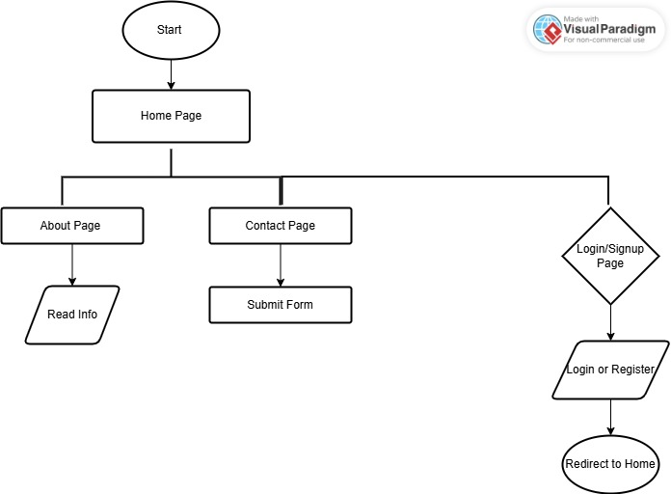

**Fig. 5.1 Flow Chart**

**5.2E-R Diagram**

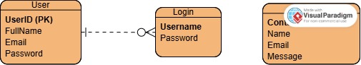

**Fig.5.2 E-R Diagram**

**5.3 Data flow Diagram (0 to 1 level)**

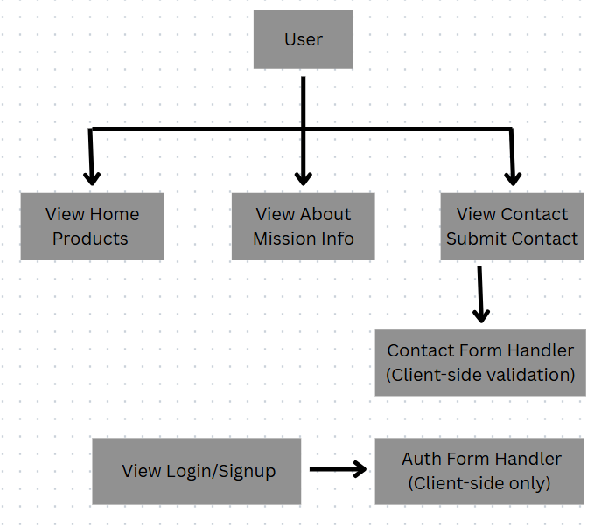

**Fig.5.3 Data Flow Diagram**

**6.IMPLEMENTATION (SCREENSHOT)**

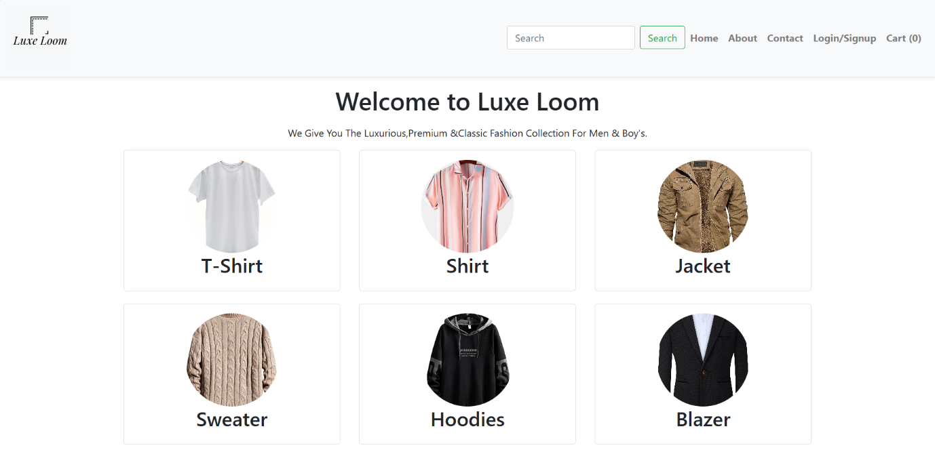

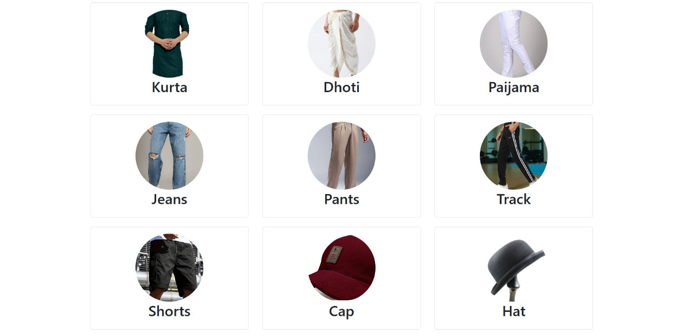

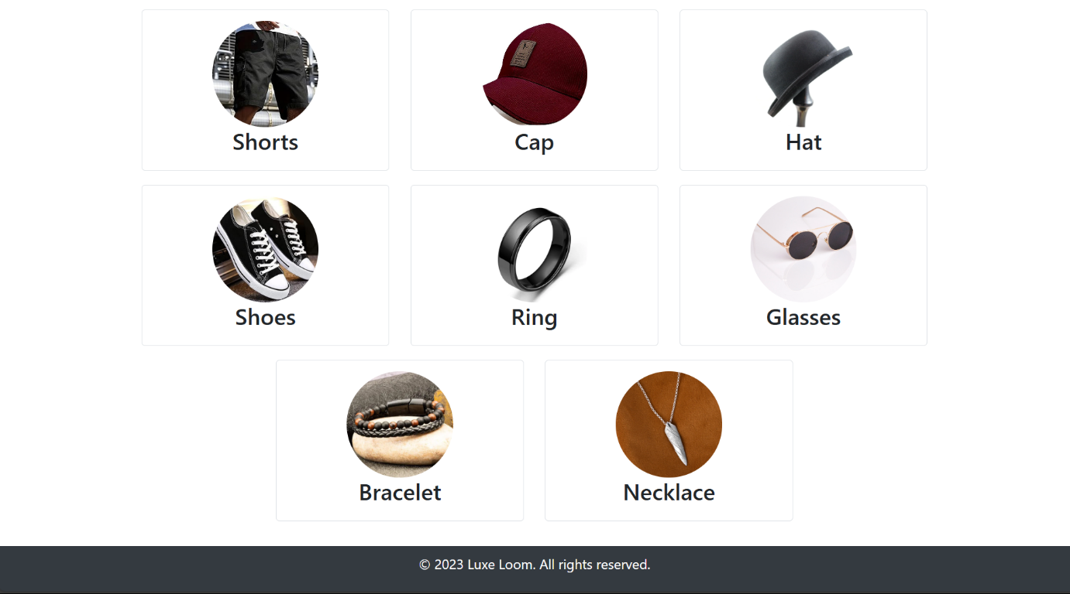

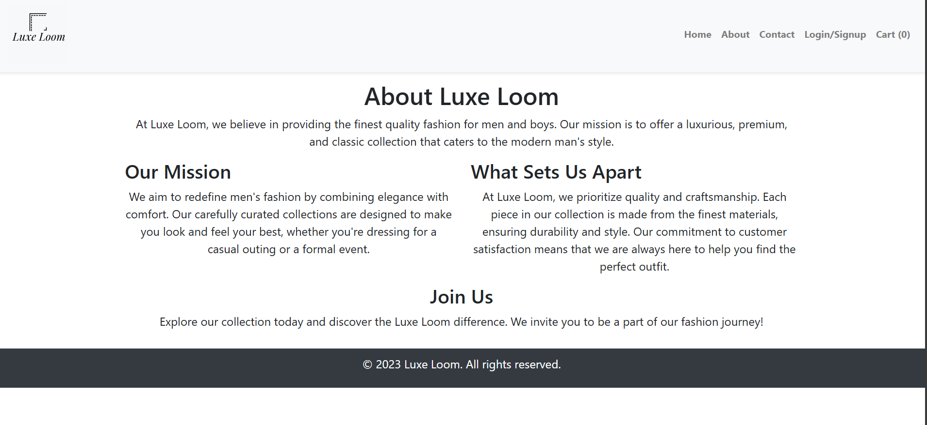

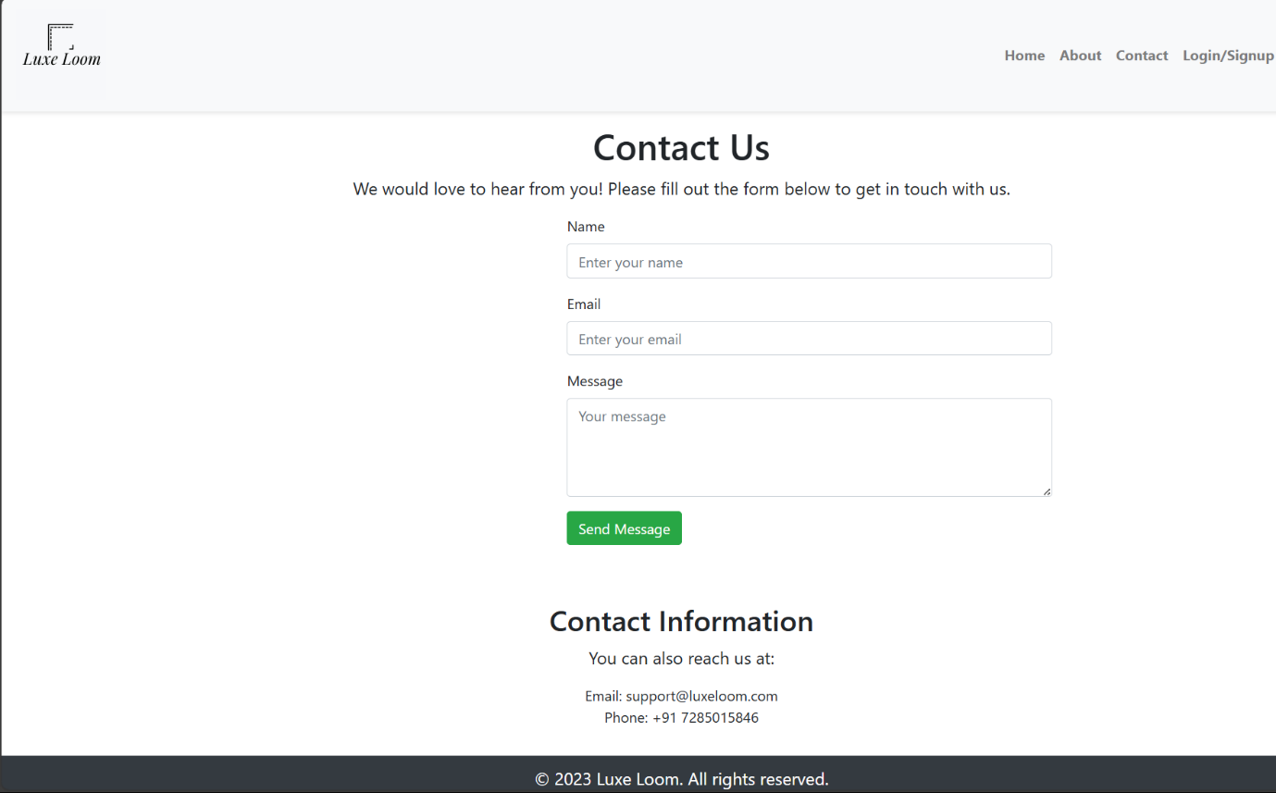

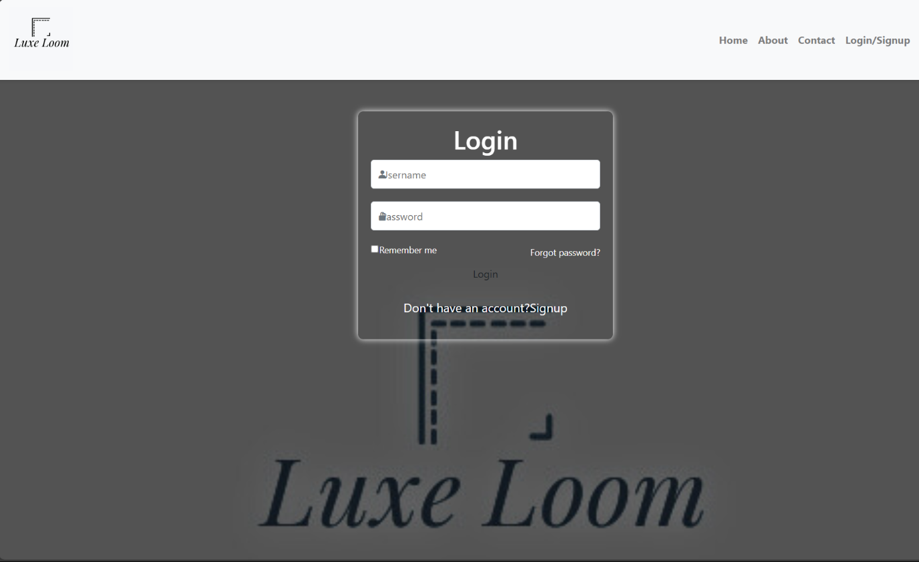

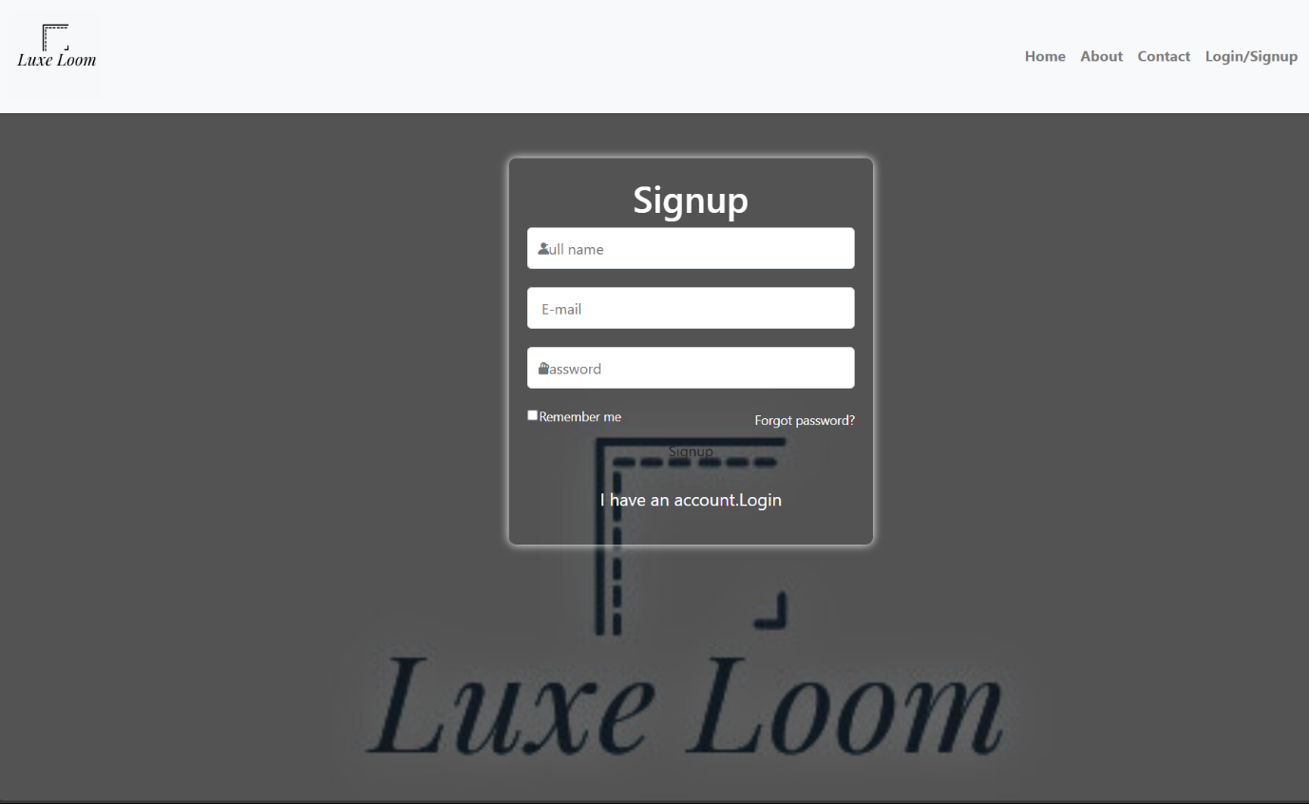

**7. FURTHER ENHANCEMENTS**

**1. Add Product Detail Pages**

* **Current State:** Products on the homepage link to either blank or placeholder pages.
* **Enhancement:** Create detailed product pages for each item with description, size, material, price, and image gallery.

**2. Front-End Form Validation**

* Add JavaScript-based real-time validation for:
  + **Login/Signup** fields (check email format, password strength).
  + **Contact Form** (ensure message is not empty, name is valid).
* Provide immediate feedback (e.g., “Password too short”, “Invalid email”).

**3. Add Testimonials/Reviews Section**

* Include customer feedback or user testimonials on the **About** or **Home** page to build trust.

**4. Improve UI/UX Design**

* Add **hover effects**, **product quick views**, and **image sliders** for a modern, interactive feel.
* Consider integrating **animations** using libraries like **AOS.js** or **Framer Motion**.

**5. Dark Mode Support**

* Allow users to toggle between light and dark themes for better accessibility and personal preference.

**6. SEO Optimization**

* Use semantic HTML tags (<main>, <section>, <article>, etc.).
* Add meta tags for description and keywords.
* Use **alt** tags for all product images to improve search engine ranking.

**7. Progressive Web App (PWA) Conversion**

* Convert the front-end site into a PWA to enable offline access, push notifications, and better mobile support.

**8. Cart Logic Improvement (Client-side Only)**

* While backend is excluded, you can:
  + Store cart data using **localStorage**.
  + Allow basic cart operations (add/remove items, show total).

**9. Add Analytics Integration**

* Include **Google Analytics** or **Facebook Pixel** to track user behavior, traffic sources, and conversions.

**10. Navigation Enhancements**

* Add a **sticky header** and **breadcrumb navigation** to improve page structure and user experience.

**8. CONCLUSION**

Luxe Loom is a well-structured front-end e-commerce website dedicated to men's luxury fashion. Developed using HTML, CSS, JavaScript, and Bootstrap, it offers a clean, responsive, and user-friendly interface. The site includes essential pages such as Home, About, Contact, Login, and Signup, allowing users to explore collections, understand the brand, and interact through forms. Although it currently lacks back-end functionality, Luxe Loom provides a solid foundation for further development. With potential enhancements like product detail pages, form validation, and UI improvements, Luxe Loom can evolve into a fully functional and visually appealing fashion platform for modern male consumers.

1. **REFERENCES**
   * Visual Paradigm. (n.d.). Online Diagram Software - Visual Paradigm Online. Retrieved from https://online.visual-paradigm.com
   * (Use this for referencing Flowchart, E-R Diagram, or DFD if created or studied using Visual Paradigm Online.)
   * Canva. (n.d.). Free Flowchart Maker and Diagram Tools. Retrieved from <https://www.canva.com>
   * (Use this for referencing any diagrams like Flowcharts, E-R diagrams, or DFDs created or explored on Canva.)
   * W3Schools. (n.d.). *HTML Tutorial*.

Retrieved from https://www.w3schools.com/html/

* + JavaTpoint. (n.d.). *HTML Tutorial*.

Retrieved from https://www.javatpoint.com/html-tutorial

* + W3Schools. (n.d.). *CSS Tutorial*.

Retrieved from https://www.w3schools.com/css/

* + JavaTpoint. (n.d.). *CSS Tutorial*.

Retrieved from https://www.javatpoint.com/css-tutorial

* + W3Schools. (n.d.). *JavaScript Tutorial*.

Retrieved from https://www.w3schools.com/js/

* + JavaTpoint. (n.d.). *JavaScript Tutorial*.

Retrieved from https://www.javatpoint.com/javascript-tutorial

* + W3Schools. (n.d.). *Bootstrap Tutorial*.

Retrieved from https://www.w3schools.com/bootstrap/

* + Google Images. (n.d.). *Various Product and Design Images*.

Retrieved from <https://images.google.com/>

* + Canva. (n.d.). *Logo Design Tool*. Retrieved from <https://www.canva.com/>